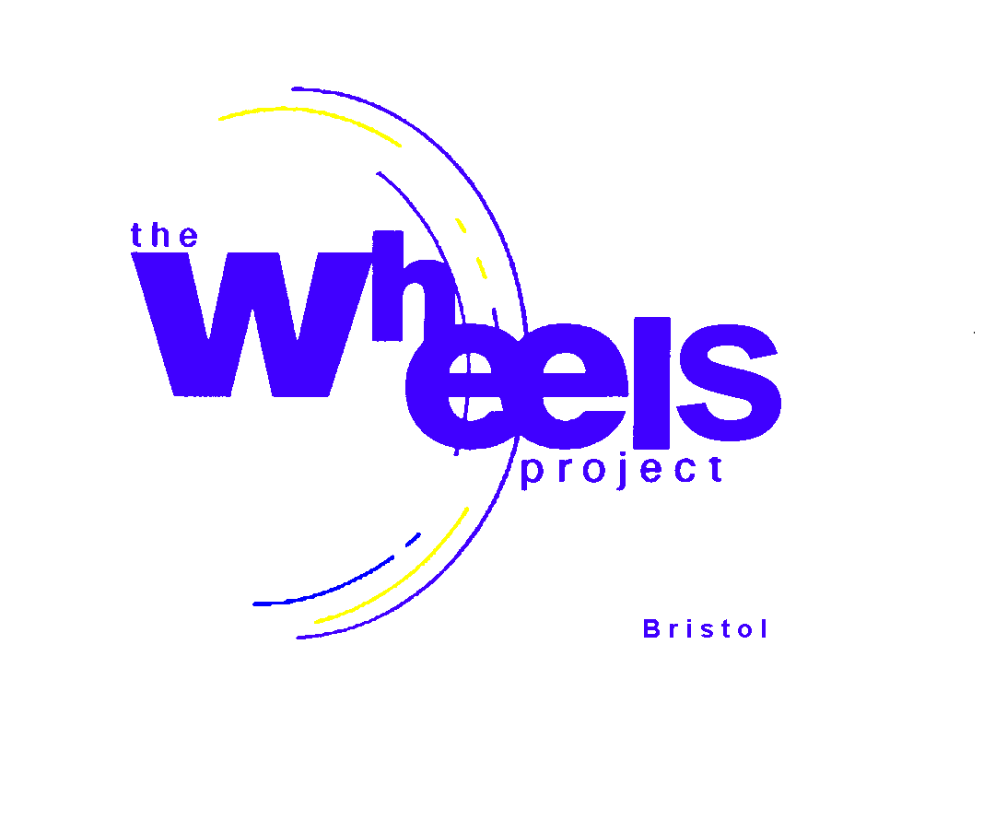
THE WHEELS PROJECT LTD
31-32 Bonville Road
Brislington
Bristol BS4 5QH
Registered Charity No: 1081236

CODE OF CONDUCT FOR STAFF
(IN AN EDUCATIONAL ENVIRONMENT)

- Purpose: The Code of Conduct for staff at The Wheels Project aims to establish clear guidelines and expectations for professional behaviour, ethics, and responsibilities. This policy serves to promote a positive work culture, uphold the reputation of The Wheels Project, and ensure a safe and conducive learning environment for students and colleagues.
- Professionalism and Integrity:
a. Staff members shall maintain the highest standards of professionalism and act with integrity, honesty, and fairness in all interactions with students, colleagues, parents/guardians, and the community.

b. Employees shall avoid conflicts of interest and refrain from engaging in any activities that could compromise The Wheels Project’s reputation or impartiality.
- Respectful and Inclusive Behaviour:
a. All staff members are expected to treat each other, students, parents/guardians, and visitors with respect, dignity, and courtesy regardless of their background, race, ethnicity, gender, sexual orientation, religion, or any other characteristic.

b. The Wheels Project promotes a culture of inclusivity, and staff should foster an environment that is free from discrimination, harassment, and bullying.

- Professional Boundaries:

a. Employees shall maintain appropriate professional boundaries with students and avoid any behaviour that could be perceived as inappropriate, abusive, or exploitative.

b. Staff members must not engage in any romantic or improper relationships with students, as such behaviour is strictly prohibited.

- Confidentiality and Privacy:

a. Staff members shall respect and safeguard the privacy and confidentiality of student records and sensitive information obtained in the course of their work.

b. Personal and sensitive information shared by students, colleagues, or parents/guardians should not be disclosed to unauthorized individuals or used for personal gain.

- Safety and Security:

a. Employees are responsible for maintaining a safe and secure learning environment. They should be vigilant in identifying and reporting any safety concerns or potential risks.
b. Staff members must adhere to emergency protocols and take appropriate action in case of emergencies or critical incidents.

- Attendance and Punctuality:

a. Staff members are expected to maintain regular attendance and punctuality. In case of unavoidable absences, employees should promptly inform their supervisors and follow established procedures for requesting leave.

- Compliance with Policies and Regulations:

- All staff members must familiarize themselves with The Wheels Project’s policies, procedures, and regulations and comply with them accordingly.

b. Failure to adhere to policies or violations of regulations may result in disciplinary action.

- Continuous Professional Development:

a. Employees are encouraged to engage in continuous professional development to enhance their skills, knowledge, and expertise in their respective fields.

- The Wheels Project may provide opportunities and resources for professional growth and learning.

- Social Media and Online Conduct:

- Staff members should exercise caution and discretion when using social media and other online platforms. Avoid posting content that could reflect negatively on The Wheels Project or compromise professional integrity.
- Respect the privacy and dignity of students and colleagues in online interactions.

- Reporting Violations: Any staff member who becomes aware of a violation of this Code of Conduct is obligated to report it promptly to their supervisor, department head, or designated authority.
- Consequences of Non-Compliance: Non-compliance with this Code of Conduct may lead to disciplinary action, up to and including termination of employment, in accordance with The Wheels Project’s policies and procedures.
By adhering to this Code of Conduct, staff members demonstrate their commitment to fostering a positive, safe, and respectful educational environment for everyone involved. This policy is subject to periodic review and updates to ensure its continued relevance and effectiveness.

