**THE WHEELS PROJECT LTD**

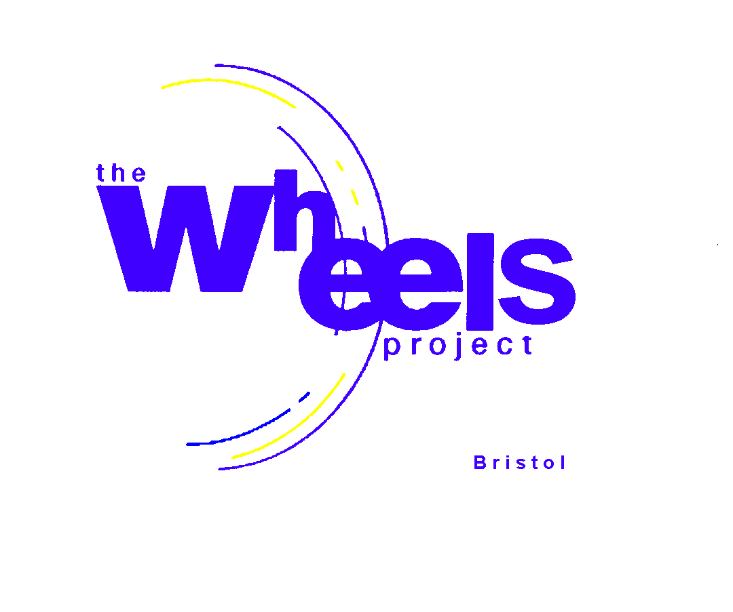

**31-32 Bonville Road**

**Brislington**

**Bristol BS4 5QH**

***Registered Charity No: 1081236***

|  |
| --- |
| **SPECIAL EDUCATIONAL NEEDS**  **Statement of Intent** |

**1 DEFINITION OF SPECIAL EDUCATION NEEDS**

Pupils have special education needs if they have a *learning difficulty* which calls for *special educational provision* to be made for them.

Pupils have a *learning difficulty* if they:

* have a significantly greater difficulty in learning than the majority of children of the same age.
* have a disability which prevents or hinders them from making use of educational facilities of a kind generally provided for children of the same age in schools within the area of the local education authority.
* are under compulsory school age and fall within the definition above or would so do if special educational provision were not made for them.

Pupils must not be regarded as having a learning difficulty solely because the language or form of language of their home is different from the language in which they will be taught.

**2 STATEMENT OF INTENT**

The Wheels Project will use its reasonable endeavours to make reasonable adjustments to accommodate those special education needs which are identified to us in writing by the relevant referrer prior to our accepting such student onto one of our courses – with a view to facilitating such student participating to the fullest reasonable extent in the activities of the Project. If the Project considers that the accommodation of such needs would place an additional financial burden upon the Project such that the Project might need to raise additional charges to the referrer, then we shall endeavour to notify you of this prior to us accepting the student on the relevant course.

The Wheels Project will have regard to the Code of Practice when carrying out its duties toward all pupils with special educational needs.

Partnership with parents, guardians, carers, or social workers play a key role in enabling children and young people with special educational needs to achieve their potential. The Wheels Project recognises that parents hold key information and have knowledge and experience to contribute to the shared view of a child’s needs and the best ways of supporting them. Parents, guardians, carers and/or social workers of children with special educational needs will be treated as partners and supported to play an active and valued role in their children’s education.

Young people with special educational needs often have a unique knowledge of their own needs and their views about what sort of help they would like to help them make the most of their education will be ascertained. They will be encouraged to participate in all the decision-making processes and contribute to the assessment of their needs, the review and transition process.

**How the Wheels Project addresses pupils with SEN**

In the first instance, the Wheels Projects identifies the special educational needs via the risk assessment form or through someone from the Wheels Project calling the organisation referring the pupil. Amongst other things, we will gain further information about any special educational needs or disabilities we need to be aware of and to find out how we can best support the pupil.

If not already done so, we then ask referring organisations to confirm details via a form. A further phone call may be required.

Unless we have been informed otherwise prior to the pupil attending a Wheels Project course, we assume:

* there are no specific special educational needs or disabilities we need to cater for
* that no adult will be attending to be with any pupil
* no external resources will be needed (e.g., a sign language translator)

We reserve the right to refuse attendance for any pupil if we feel we cannot reasonably accommodate any special educational needs or disabilities or in the case of unreasonable behaviour. Please see our separate Students Behaviour Policy for more details on this.

GDPR

We are fully compliant with the General Data Protection Regulation which came into force on 25 May 2018. Our privacy policy can be found on our website <https://wheelsproject.org.uk/privacy-policy/>. In particular, please note what data we need to collect and how we make sure it is kept safe.